
Lesson 5 Teacher's Key
GDevelop
INSTRUCTOR ONLY - do not distribute to students

Level 1 - Complete Worked Solution
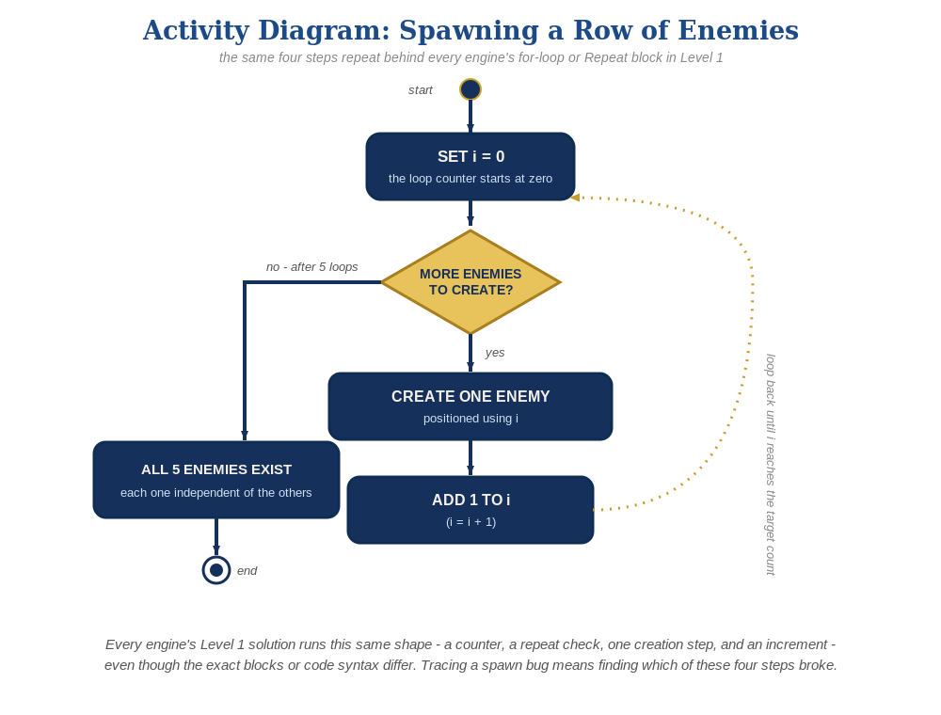
The spawn loop, in general - the same counter, repeat check, creation step, and increment behind Level 1 in every engine, whatever the exact blocks or syntax look like.
A "Repeat 5 times" event at the beginning of the scene, using a new EnemyIndex scene variable - the Combat event group from Lesson 4 needs zero changes:
At the beginning of the scene:
Repeat 5 times:
Action: Create object Enemy at (40 + EnemyIndex * 80, 40)
Action: EnemyIndex = EnemyIndex + 1

Level 2 - Complete Worked Solution
The "Bullet is in collision with Enemy" condition and its Delete actions already operate per pair of overlapping instances, so every instance the Repeat event creates behaves independently and correctly with no extra events needed for Level 2.

Level 3 - All Worked Solutions
Every stretch-goal idea from the handout, fully worked - not just one. Useful for validating each idea actually works before class, and as a ready reference no matter which one a student ends up picking.

Sound: already works
The "Play a sound" action inside the Combat event group runs independently for every enemy that gets hit - no changes needed.

Visual: striped row
Tint each Enemy differently as it's created, based on whether EnemyIndex is even or odd. "200;25;55" is a deep crimson red and "230;100;130" is a lighter dusty rose/pink (GDevelop's Tint color action takes an "R;G;B" string) - alternating them makes every other enemy a visibly different shade of red, not a blended new color:
Repeat 5 times:
Action: Create object Enemy at (40 + EnemyIndex * 80, 40)
Condition: EnemyIndex mod 2 = 0
Action: Tint color of Enemy = "200;25;55"
Condition: EnemyIndex mod 2 = 1
Action: Tint color of Enemy = "230;100;130"
Action: EnemyIndex = EnemyIndex + 1

Structure: group the spawn loop separately
Put the Repeat spawn event in its own labeled group (e.g. "Spawn Enemies"), separate from the "Combat" group from Lesson 4 - the two mechanics stay easy to find as the event sheet grows.

Complete Level 3 solution (all 2 goals combined)
The spawn Repeat event with the visual idea added, as its own group - sound needs no changes since it already lives in the Combat group:
Event group: "Spawn Enemies"
At the beginning of the scene:
Repeat 5 times:
Action: Create object Enemy at (40 + EnemyIndex * 80, 40)
Condition: EnemyIndex mod 2 = 0
Action: Tint color of Enemy = "200;25;55"
Condition: EnemyIndex mod 2 = 1
Action: Tint color of Enemy = "230;100;130"
Action: EnemyIndex = EnemyIndex + 1

